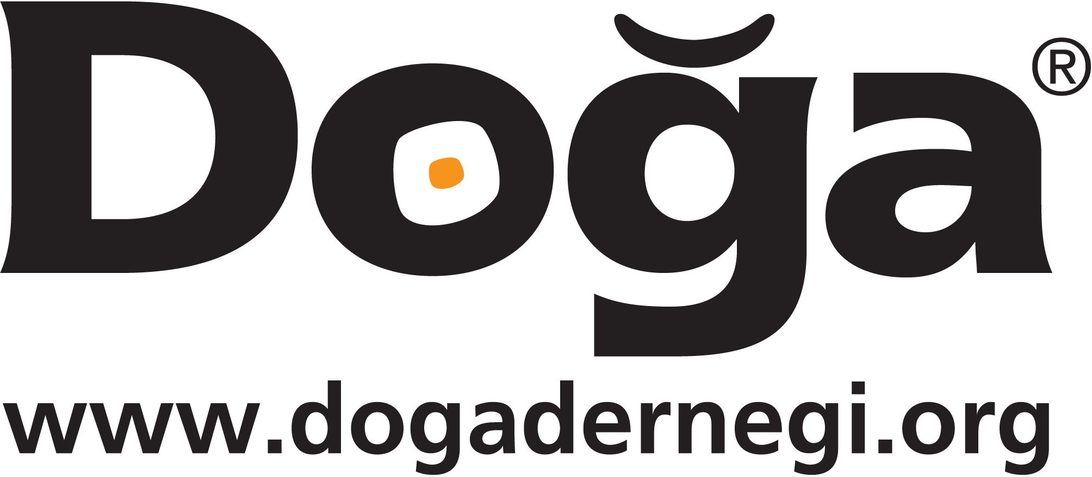

Doga Dernegi (Birdlife Turkey) is looking to recruit a qualified officer for migratory species conservation

Job Title: Flyway Project Officer
Ref: FPO2013
Reporting To: Conservation Manager
Location: Istanbul-Hatay
Period of Contract: Full-time initially for 18 months, with a probationary period of 6 months
Post holder reports to: DD Conservation manager
Other working relationships: Doğa Derneği Team, relevant government authorities, Birdlife International and RSPB, NGO’s and Universities.

Organisation: Doga Dernegi (DD) is one of the largest and most influential non-governmental organisations in Turkey working in the field of environmental conservation. Its mission is to protect wildlife and their habitats for people in Turkey. It is internationally recognised for its efforts and is the Turkish representative of BirdLife International, a global network of nature conservation organisations.

Main Duties
- Assessment of the existing agreements/legislation, whether international or national, on energy sector infrastructure threats to migratory birds
- Monitoring the enforcement of the existing agreements/legislation, whether international or national and initiate relationships with the related enforcement agencies
- Providing information to decision makers in order to improve their understanding and knowledge on illegal hunting
- to develop and conduct questionnaires for hunting societies concerning their perception of hunting and related legislation
- Improve local capacity on monitoring programmes
- Promote responsible hunting through Mass Media
- Establishing a consultation mechanism between hunters and local conservation groups
- Translate, adopt and publish birdlife guidelines and circulate among the relevant decision makers and stakeholders
- Promotion of best practice guidelines through mass and local media
- Identification of threats and undertake campaigning for enforcement of mitigation measures
- Enhance and maintain local partnerships with key stakeholder groups
- Providing information to decision makers in order to increase their capacity on energy sector
- Contribute to the DD’s species conservation work with special focus on migratory species.
- to contribute to the regular annual reports and project reports of DD

Qualifications:
- A university degree from a relevant field of expertise. (Advanced university degree is preferred)
- Minimum 1 year practical experience in bird research and/or conservation projects.
- Driver licence
- Good research, analytical and problem-solving skills,
- Positive, flexible, solutions-oriented
- Works collaboratively with colleagues to achieve organizational goals
- Competent with Microsoft Office programs
- Well organised with demonstrable ability to manage projects
- Good command in English,
- Ready to cope with busy work schedules and flexible working hours,

Please return your fully completed application form to Doğa at doga@dogadernegi.org together with a covering letter quoting ‘Ref: FPO2013’ by 10th March 2013.

CVs will not be considered.

