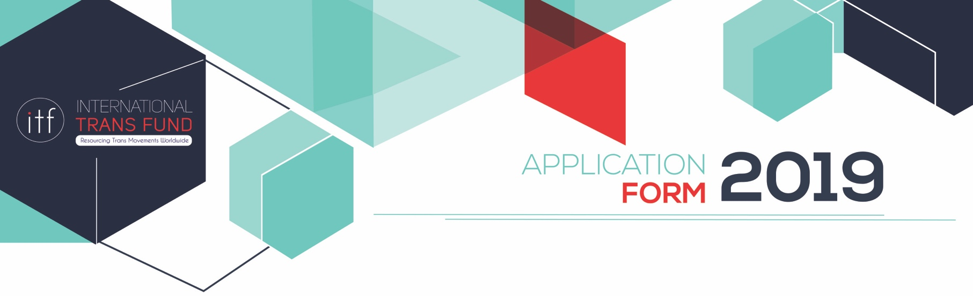

The International Trans Fund (ITF) is pleased to announce our third grantmaking cycle. We warmly welcome applications from trans-led groups with budgets below $150,000 USD based in any region of the world. The deadline to apply is December 1, 2018 at 5pm (ET/New York time).

We require all groups to complete the ITF’s application form. We strongly encourage you to read the Application Guidelines which are available on our website (www.transfund.org). If you have questions, please contact info@transfund.org.

Eligibility Criteria

To be eligible for funding groups must be meet the following criteria:
- Be trans-led:
  - Trans people must be in decision-making roles, including setting the organization's strategic and financial priorities, and make up 75% of the group's staff, spokespeople, and Board or decision-making body.
  - If this is not the case, groups must demonstrate how trans people make budget, organizational and strategic decisions.
- Have an operating budget under $150,000 USD.
- Be a group of people (i.e. not an individual).
- Main focus of work is to benefit the trans community.
- Contribute to movement building, not just providing direct services.

Priorities
The ITF’s priorities in this funding cycle are to:
- Fund a diversity of groups, including different regions, languages, gender identities, strategies and issues.
- Reach trans communities facing greater levels of marginalization (e.g. racism, classism, ageism, ableism, misogyny and so on).
- Support trans groups whose work contributes to social justice, trans movement building, and the liberation of trans people.

Please note the following:
- Page limit. There is a strict page limit that helps us fairly evaluate applications. Applications should not exceed eight pages. Font size should be no smaller than 11pt. Please note that in order to be fair, we will not review materials after eight pages. Additional materials (reports, strategic plans, etc.) will not be reviewed.
- Complete. Please make sure that the application form is filled in correctly and completely or your group could be found to be ineligible. This includes the financial information section in PART 3.
- Language. We accept applications in English, French, Russian, Simplified Chinese and Spanish.
- Amount. Grants will generally range in size from $10,000 to $30,000 USD. Grants up to $50,000 may be considered in special circumstances. We do not accept applications for funding of more than $50,000 or less than $5,000.
- Video: Eligible groups who are unable to write an application can submit a video recording that is no longer that 10 minutes and fully answers the questions below. Please see Application Guidelines for more details.

ITF Application Form
This application should not exceed eight pages including the form. Please answer all questions in the fields provided. Do not change or reformat the form.

PART 1: Organizational Background

- Name of your group:

- Country where your group is based:

- Where do you do your work (local, national, regional, international):

- What year was your group formed:

- List two designated contact people that we can communicate with about this application.
Main Contact (this is the person we will write to about your application)
Name
Position in the organization
Email
Phone

Secondary Contact
Name
Position in the organization
Email
Phone

- Contact information for the group:
Email
Phone
Website
Social media (Facebook, Twitter, Tumblr)

- What are the main issues facing the trans community where you work? (150 words)

- What is the gender identity/expression of the majority of individuals you work with? (Please mark ‘X’ on the best answer)
Third gender cultural identities (e.g. Hijra)
Trans feminine people
Trans masculine people
Trans non-binary people
Trans (all identities)
Other
If you selected ‘other’, can you briefly explain?

- Who are the three (3) main populations that your group works with? (Mark ‘X’)
Trans people of color/racial, ethnic or caste minorities |  | Trans people in rural areas
Trans indigenous people |  | Trans people in urban areas
Low-income or poor trans people |  | Trans people in conflict zones
Trans children and youth |  | Trans people with disabilities
Trans students |  | Trans people living with HIV/AIDS
Trans elders |  | Trans people who use drugs
Trans sex workers |  | Trans and intersex people
Trans migrants or refugees |  | LGBQ trans people
Trans people in prisons/incarcerated |  | Other
Trans homelessness
If you selected ‘other’, can you briefly tell us what other populations your group works with?

10. What are the three (3) main issues or topics that your group is primarily working on? (Mark ‘X’)
Access to education |  | HIV/AIDS
Access to employment |  | Legal gender recognition
Access to healthcare |  | Media
Community building |  | Mental health & wellbeing
Criminalization |  | Policy and legal change
Depathologization |  | Safety and security
Economic empowerment |  | Sexual and reproductive health
Discrimination |  | Violence prevention/hate crimes
Family issues |  | Visibility/cultural work
Health |  | Other
If you selected ‘other’, can you briefly tell us what other issues or topics you are working on?

- Briefly introduce your group. We want to know about your group’s vision, mission, key activities and partnerships (200 words).

- Describe how your group is trans-led. Tell us who makes strategic and budget decisions and list all the staff and board clearly stating their identities (see example on page 9 in the Application Guidelines). Please note that trans people should make up 75% of staff, spokespeople, and Board or decision-making body. If this is not the case, you must demonstrate concretely how trans people make budget or strategic decisions for your group.

PART 2: Funding Request

The ITF primarily gives grants between $10,000 - $30,000 USD. Grants as low as $5,000 and up to $50,000 may be considered in special circumstances. The ITF prefers to give general support/core funding to groups. However, we also give project grants if that is preferred.

- Are you requesting general support or a project grant?

- Amount requested from the ITF (request should be in USD):
- If you applied for general support, list the items you intend to cover during the grant period. If you applied for a project grant, outline the main activities your group will undertake during the grant period. It should be clear at which level (local, country, regional, international) the work will take place.

- How will your work contribute to trans movement building in your context?

- What impact would receiving this funding have on your group and/or on your work?

PART 3: Financial Information

- What was your organizational budget in 2018 (please state in USD)?
Income
Expenditure

- Has your group received external funding (grants) before?

- If yes, please list the names of your current or former funders in the last two years and the purpose of those grants.
Funder | Year(s) of funding | Amount (USD) | Purpose

- Please complete the budget template below for the grant you have requested. This must be filled in completely to show how you plan to spend the funding. Kindly note that this is a one year grant.
FUNDING REQUEST | BREAKDOWN OF ITEMS  Fully describe the items you will fund with this grant. |  | AMOUNT IN USD  State the amount of each item in US dollars
1. Core funding
This includes but is not limited to organizational, operational and staffing costs like salaries, rent, utilities, capacity building expenses and purchase of office equipment.
Total expenses for core funding
2. Project activities
This includes but is not limited to project activities like training workshops, meetings, campaigns and all costs associated with activities e.g. facilitators, transport, venue hire, meals, accommodation, etc.
TOTAL EXPENSES FOR PROJECT ACTIVITIES
TOTAL BUDGET REQUESTED
This should equal the amount you are requesting from the ITF

PART 4: Referees

- List the names of two referees who we can contact if your application is selected. These should be individuals who are familiar with your work but are not part of your group and who have given you permission to be contacted by the ITF.
Referee 1 |  | Referee 2
Name |  | Name
Position & organization |  | Position & organization
Email |  | Email
Phone |  | Phone

Application Checklist

Please check that your application is complete. Mark ‘X’ next to each item
Check (X)
Contact information for two people in your group
Organizational background (three pages or less)
Funding request (three pages or less)
Financial Information (two page or less)
Contact information for two referees
We acknowledge that the ITF will not follow up on an incomplete application

Submit your complete application form to info@transfund.org by December 1, 5pm (ET/New York time). You can find out what time that will be in your region by checking a time converter website like www.timeanddate.com.

